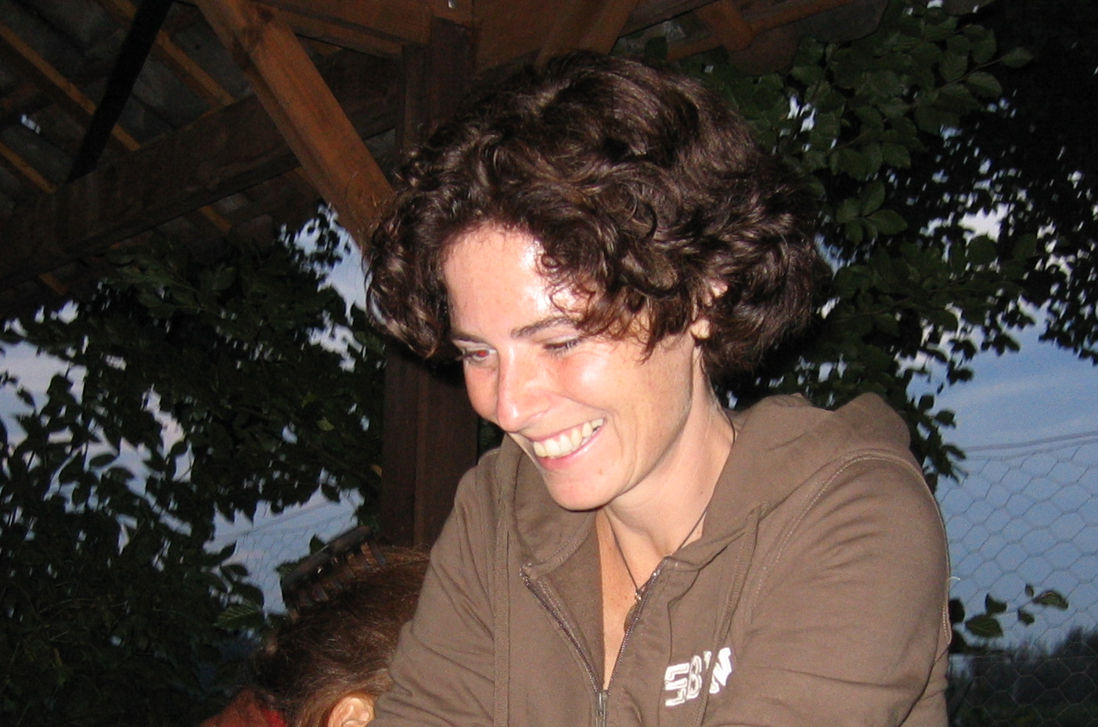
Curriculum Vitae

NAME Dr. Marianne van Wetter-Simons ADDRESS Oudwijkerveldstraat 84
DATE OF BIRTH 24th of April 1970 3581 JN Utrecht, The Netherlands
PLACE OF BIRTH Leek TELEPHONE + 31 (0)30.88 94 083
NATIONALITY Dutch MOBILE PHONE + 31 (0)6.22 047 996
MARITIAL STATUS married with Mark, 3 children, E-MAIL marianne@mountainchildcare.org
Mare, Kieke and Broes

Working experience  January 2011 – present moment  December 2007 – present moment  November 2007 – present moment  2001 - 2010  October 2004 – June 2005  February -September 2003  1996-2004  1995-2000  Education  1989-1995  November 1994 –  March 1995  1989-1992  1982-1989  Courses and training  January 2013  October 2011  2006-2012  2000-2012  2009-2010  2000-2012  2004-2006  2004  February 2000  April 1998  1996-1998  1996  1996  Travel experiences  July –August 2009  May – August 2007  June 2000 –  May 2001  Language skills  Hobbies | Founder, inspiration and coach of Mountain Child Care. Mark, my partner and I started our dream Mountain Child Care, an NGO that organizes personal leadership quests and programs for youngsters aged 17-23. It focuses on awakening the intrinsic motivation and strength of these youngsters, to make their talent work. We work in Nepal with orphans and former street children. The key element of the program is a ‘Quest Trek’, a six days hike through the Himalaya (see also www.mountainchildcare.org). Up till now we walked 17 Quest Treks and have around 170 youngsters in our program. Because of the resounding effectiveness and success we will start working in Holland with youngsters as well.  Coach and moderator during in-company culture interventions. I cooperate with Plezant, a leading music-theatre group (www.plezant.nl) in this segment. They are specialized in theatre about life and work and their plays serve as an intense eye opener at the beginning of major culture shifts in bigger Dutch organizations like hospitals, banks, government and semi- government institutions. The last two years I didn’t work a lot with them since Mountain Child Care and our children are priority number one.  Volunteer at ‘our’ kinder garden, de Bombardon in Utrecht. Parents run this kinder garden. They all take shifts in taking care of the children. All parents work half a day a week.  Entrepreneur in the network organisation Echte Welvaart (True Prosperity).  We (a network organisation of five people) invited people to take time for reflection and inspired them to choose what really adds value to their (professional) life. I worked for companies, ministries, and governments bodies and individuals. My role was that of a ‘guide’, creating an atmosphere that invites people to open up. Simply by listening and asking questions and using creative working methods that support the process. In 2010 we celebrated our 10 years of existing (see on youtube: 10 jaar Echte Welvaart) and all chose our own directions.  Doctors Without Borders, opening of a mission for primary health care in Manipur, India, place of residence Imphal and Churachanpur.  Field Logistic Administration and Finance responsible:  We were the first team to set up the mission. I was responsible for all logistics (finding a house, building a store, electricity supply, buying cars and the maintenance etc.), bookkeeping, finding and hiring staff, salary administration, security management and future planning.  Doctors Without Borders, mission in Zimbabwe, therapeutic feeding centre for malnutrition, place of residence Murambinda:  Field Logistic Administration and Finance responsible:  I was responsible for all logistics, administration and HRM.  Tour guide for SNP Nature Travels. I guided around 15 hiking tours in the Alps, Pyrenees, Himalaya and other less known mountains. I worked for them during my holidays.  University (Rijksuniversiteit Groningen); department of Biology of Plants  Ph.D. student, completed with writing and defending the thesis in February 2000  The Ph.D. consisted of different tasks:  Research: The research was focused on determining the functions of a specific group of structural proteins in the development of the fungus Schizophyllum commune. Part of the research was carried out at the University of Göttinge (Germany).  Education: Supervising groups of first year and individual senior students during their graduate projects of six months.  Other tasks: Managing of the research, giving presentations on national and international congresses and writing of scientific articles.  University (Rijksuniversiteit Groningen)  Propaedeutic Biology obtained in 1990 (cum laude).  Masters in Molecular Biology obtained in 1995 (cum laude).  Completion of the master’s degree at the university of Tel Aviv, Israel (eight months).  Assistant of the practical courses Cell Biology for first year students and Molecular Biology of Fungi and Plants for senior students  Different functions within the board of the Groninger Biology Student Club.  Havo and Atheneum (high school) at the Nienoord College in Leek. Certificate obtained.  Fundamentals Co-Active coaching  Motivational Interviewing  Several constellation workshops (organisation constellations and family constellations)  Seven 10 day-Vipassana retreats  Iyengar Yoga Teacher training, only first year completed, Amsterdam, Iyengar Institute, Holland  Several yoga workshops  Yoga Teacher training, level 1 and 2, Utrecht, Yoga Moves, Holland, certificate obtained  France language course, Alliance Francaise, Utrecht, Holland  One month yoga course, Mysore, India  Dynamic presentation  For tour guiding; first aid, mountain hiking with groups, groups processes, general geology and navigation in the field.  Research management  Hebrew language course, Haren, Holland  Pilgrimage on foot from Maastricht (South of Holland) to Cluny (middle of France) together with Mark, Mare (3 years old) and Kieke (6 weeks old). We walked 1000 km, finalizing our 3300 km pilgrimage from home to Santiago de Compostela.  A 2300 km pilgrimage (honeymoon) on foot from Utrecht, Holland to Santiago de Compostela, Spain, together with Mark and daughter Mare, at that time 9 months old. Due to lack of time we took the train from Maastricht to Cluny.  Travelling and working in Asia especially in Nepal, India and Vietnam. I spent for at least three months in each country to get familiar with the culture, the people and the habits.  - Guiding a tour in Nepal  - Guiding a tour in Vietnam  - Buddhist meditation retreats (Kathmandu, Nepal)  - 1 month Yoga course (Mysore, India)  - 10 day Vipassana retreat (Kathmandu, Nepal)  Fluent in Dutch and English, basic knowledge of German, French and Nepali  Yoga, (mountain) hiking, travelling, reading

